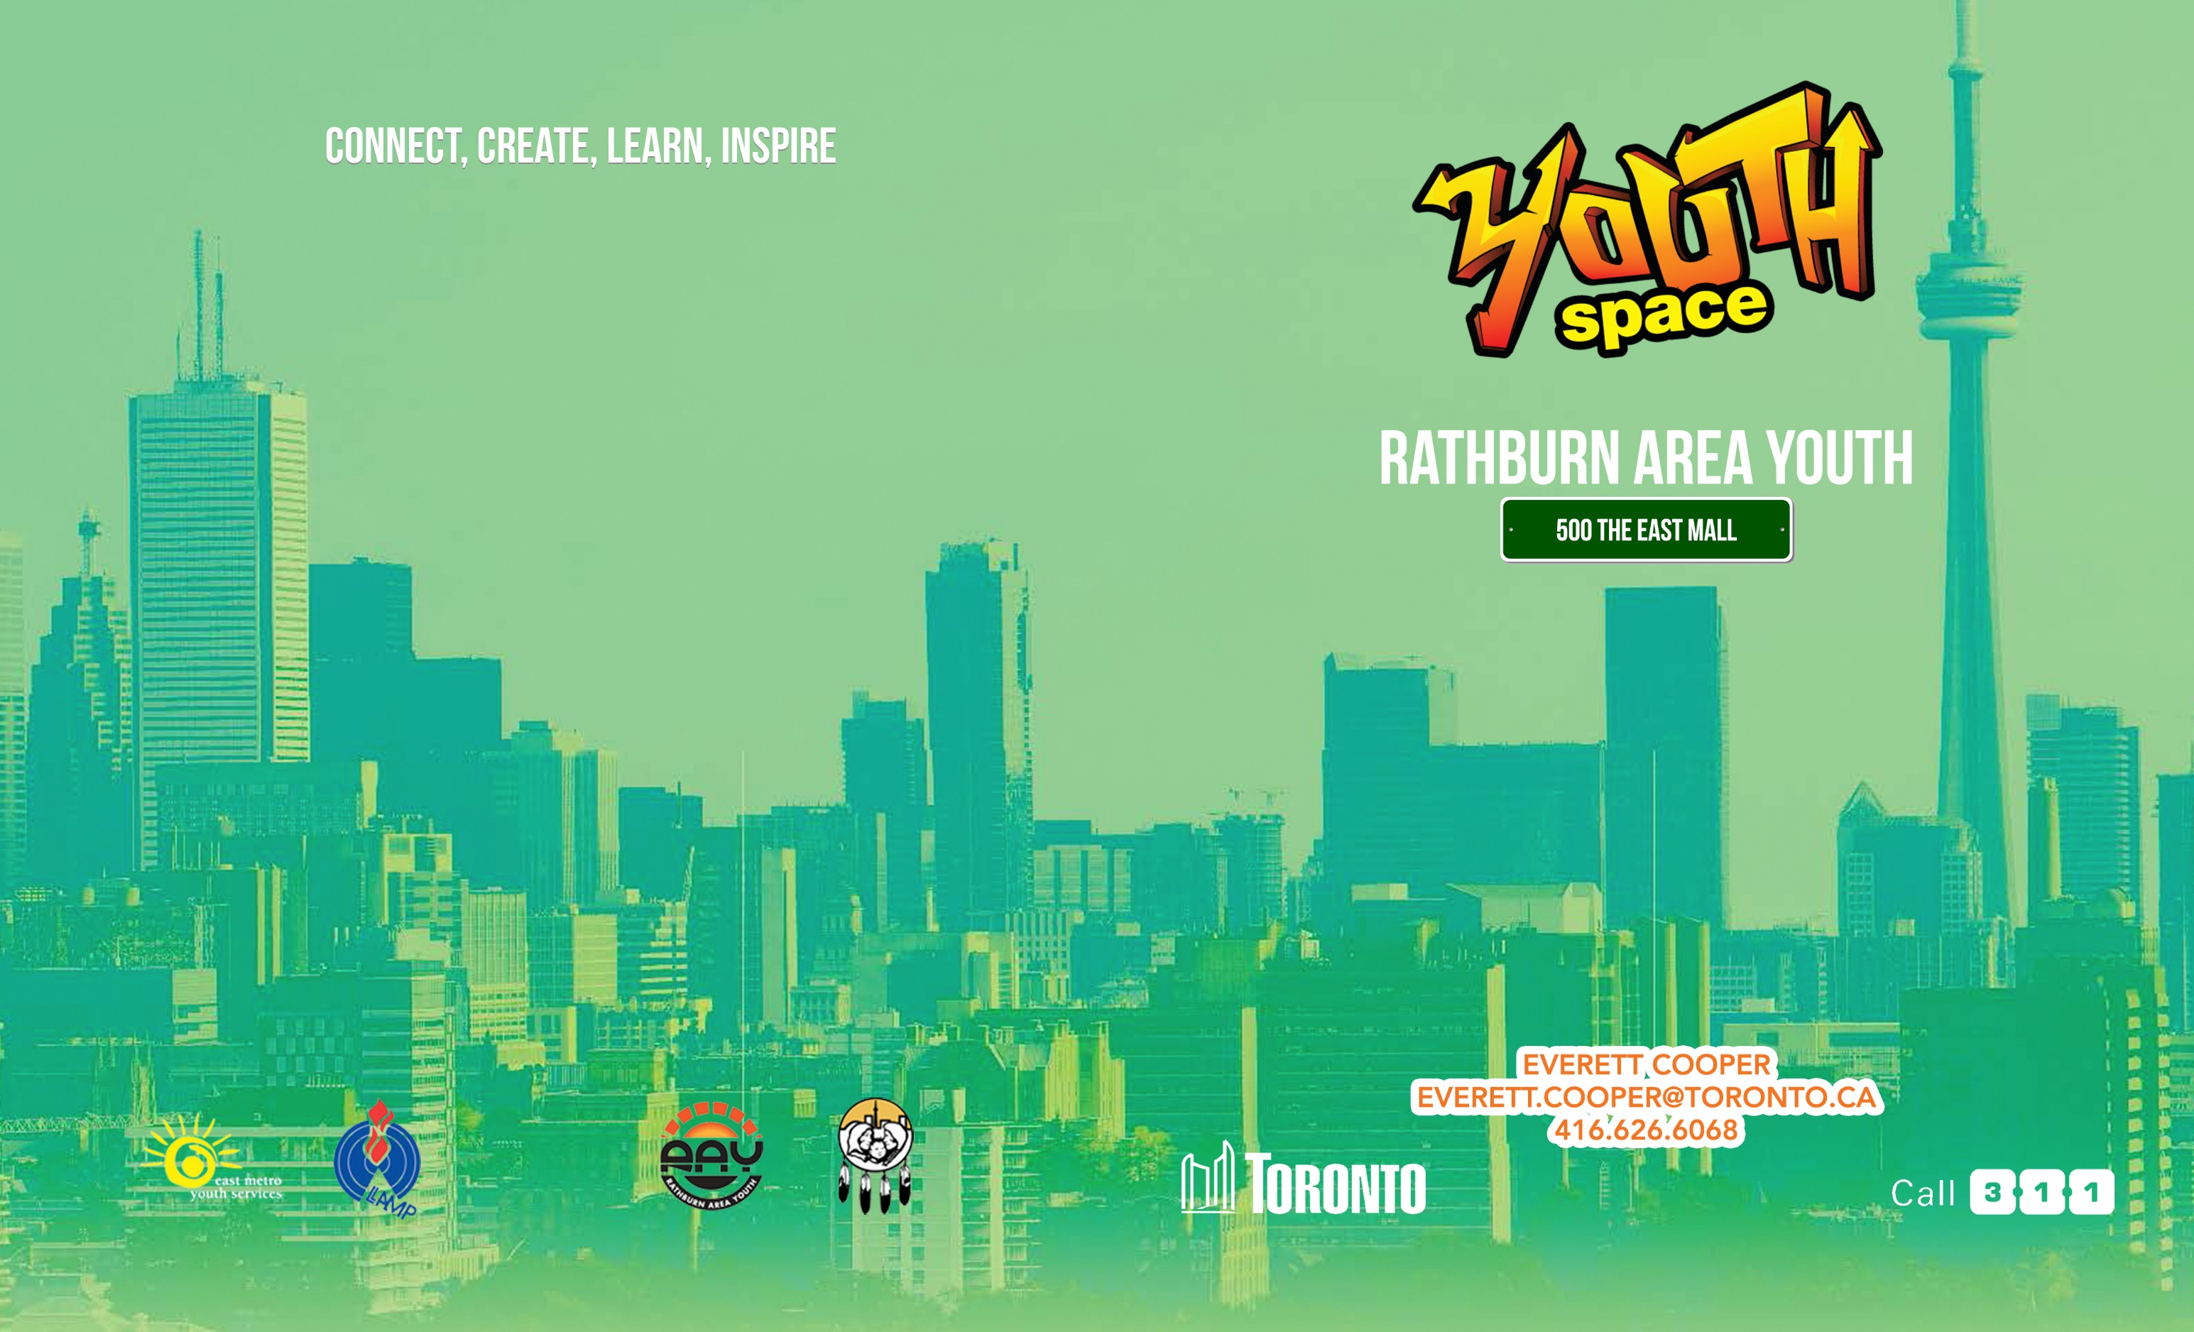

Monday | Tuesday | Wednesday | Thursday | Friday
12:00pm-1:00pm  Ice Breakers  Chill Zone/Gym  12-24years | 12:00pm-1:00pm  Ice Breakers  Chill Zone/Gym  12-24years | 12:00pm-1:00pm  Ice Breakers  Chill Zone/Gym  12-24years | 12:00pm-1:00pm  Ice Breakers  Chill Zone/Gym  12-24years | 12:00pm-1:00pm  Ice Breakers  Chill Zone/Gym  12-24years
1:00pm-2:00pm  R.A.Y Kitchen  12-24years | 1:00pm-2:00pm  R.A.Y Kitchen  12-24years | 1:00pm-2:00pm  R.A.Y Kitchen  12-24years | 1:00pm-2:00pm  R.A.Y Kitchen  12-24years | 1:00pm-2:00pm  R.A.Y Kitchen  12-24years
2:00pm-5:00pm  The Build Up  12-24years | 2:00pm-3:00pm  IYE Leadership Workshop  12-24years | 2:00pm-5:00pm  Carnival Arts Workshop  12-24years | 2:00pm-5:00pm  Designers workshop  12-24years | 2:00-5:00pm  R.A.Y Arena  12-24 years
3:00pm-5:00pm
IYE Leadership
12-24years

Summer 2018

Monday | Tuesday | Wednesday | Thursday | Friday
12:00pm-1:00pm  Ice Breakers  Chill Zone/Gym  12-24years | 12:00pm-1:00pm  Ice Breakers  Chill Zone/Gym  12-24years | 12:00pm-1:00pm  Ice Breakers  Chill Zone/Gym  12-24years | 12:00pm-1:00pm  Ice Breakers  Chill Zone/Gym  12-24years | 12:00pm-1:00pm  Ice Breakers  Chill Zone/Gym  12-24years
1:00pm-2:00pm  R.A.Y Kitchen  12-24years | 1:00pm-2:00pm  R.A.Y Kitchen  12-24years | 1:00pm-2:00pm  R.A.Y Kitchen  12-24years | 1:00pm-2:00pm  R.A.Y Kitchen  12-24years | 1:00pm-2:00pm  R.A.Y Kitchen  12-24years
2:00pm-5:00pm  The Build Up  12-24years | 2:00pm-3:00pm  IYE Leadership Workshop  12-24years | 2:00pm-5:00pm  Carnival Arts Workshop  12-24years | 2:00pm-5:00pm  Designers workshop  12-24years | 2:00-5:00pm  R.A.Y Arena  12-24 years
3:00pm-5:00pm
IYE Leadership
12-24years
Designer Warehouse
The DW program provides participants with Graphic Machinery to create Visual designs, Logos, T-shirts, Images and knowledge to navigate digital media forms (e.g. Photo-shop)

RAY ARENA
The Arena will consist of game completions such as Ping Pong, 2k, Pool, dominoes and more. With each gaming event points will be calculated at the end of the night and after a period of 9-13 weeks whoever has the most points per event wins a prize. As the events are going educational movies will play in the common area.

The Build Up
An opportunity for participants to engage in team building activities to develop Self-awareness, Interpersonal, and Leadership skills

Carnival Arts
The Carnival Arts program aims to provide participants with tools and materials to create artistic pieces such as Fashion designing, Graphic Designing and opportunity to incorporate cultural traditions with Foods and Musical arts.

RAY Kitchen
RAY Kitchen is a program that runs on a day to day basis. Youth have the opportunity to learn new recipes and practice culinary arts. It is a great way to teach youth basic life skills. This program also promotes team work and nutrition. Providing a safe space for youth to debrief and receive council and support in a casual environment.

Ice Breakers Chill Zone
Chill Zone provides an enjoyable, welcoming, safe environment for youth aged 12-24. We providing an open space with the ability to engage in fun activities, eat healthy snacks, lounge around, full access to computers, popular gaming systems, crafts and entertainment. The chill zone is the summer 2018 place to be.

